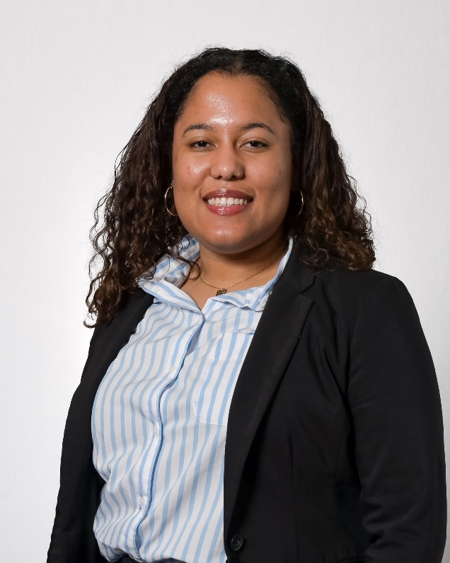

**Sarah Lopez**

Sarah Lopez is a driven public servant, currently serving as the Outreach Assistant for the 4th Congressional District of Connecticut in the Office of U.S. Senator Chris Murphy. During her time in the U.S Senate, Sarah has worked to represent the constituents of her district, and, importantly, translate the lived experiences of underserved communities, like her hometown of Bridgeport, into policy.

Her family’s Dominican and Honduran heritage inspired her to pursue a Bachelor’s degree in International Relations from Boston University with a focus in Latin American politics. Her passion is in empowering young people in politics and building stronger democracies through civic education and engagement.

Sarah also serves on the board of The Foodshed Network, a food justice advocacy group based in Greenwich.