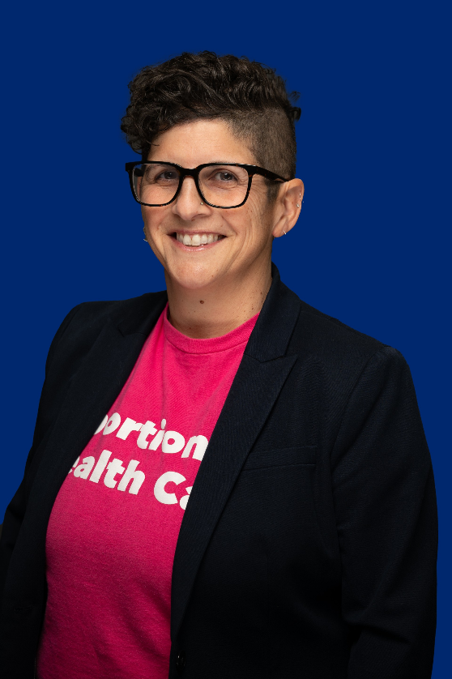

**Gretchen Raffa**

**Gretchen Raffa, Chief Policy and Advocacy Officer at Planned Parenthood of Southern New England, Planned Parenthood Votes! CT and Planned Parenthood Votes! RI**has dedicated her professional career to advocating for reproductive freedom. Gretchen leads the strategic direction for legislative affairs and represents PPSNE on numerous coalitions and lobbying at the State Capitol in both states. Gretchen leads a team across two states, developing and executing strategies to advance the organizing, advocacy, policy, and electoral priorities of the organizations with a goal to expand laws and policies that increase access to health care for all people. Gretchen is a graduate from the University of Connecticut and received her MSW with a concentration in Policy Practice at University of Connecticut School of Social Work.