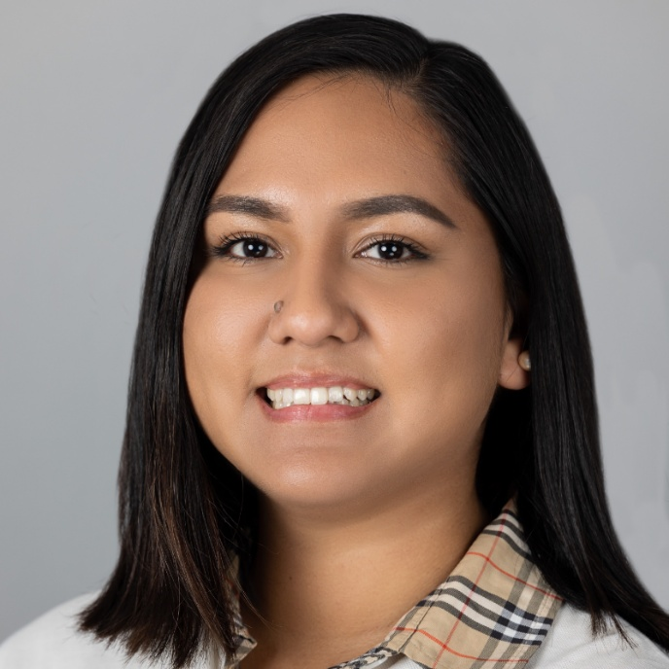

**Gabriela Koc**

Gabriela Koc (pronounced coke) is a dynamic young leader who has dedicated her career to public service and systems change work from politics, policy, and programming. She currently works at the Office of the State Treasurer as the Engagement Manager in the executive division, working on promoting and spreading awareness on the work of the office and programs it administers in service to the residents of CT. She is also a local elected official serving on the Stamford Board of Education as the Policy Chair where she works with various stakeholders as well as high school student leaders to have a voice at the table. Gabriela is a first-generation college graduate and proud immigrant born in Venezuela to Peruvian parents. Her family’s story and experiences with political violence in their native country influenced her to get involved in politics and activism from a young age. She has held various leadership positions in party politics advocating for progressive causes and is currently serving as Eastern Vice President for the Young Democrats of America. In her free time, she enjoys learning more about her indigenous heritage, eating Peruvian food, and traveling to other states with her husband Reno.