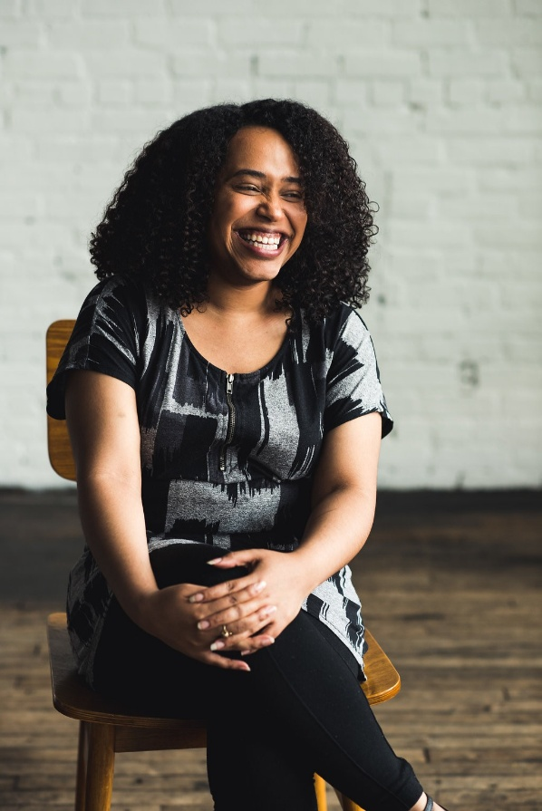

**Francis Nunez**

Francis Nunez (She/Her/Ella) is currently the director of organizing and campaigns for Planned Parenthood of Southern New England. She started organizing in local elections in her hometown of Newark, NJ, but honed her skills right here in Connecticut doing education equity work in Bridgeport, Connecticut and across the state.

Throughout her decade long career, she has built power to change public policy in harm reduction/decarceration, immigration, housing, and of course, reproductive rights and access with Planned Parenthood. She believes deeply in the power of people to improve the quality of their lives and communities through grassroots organizing and leadership development.