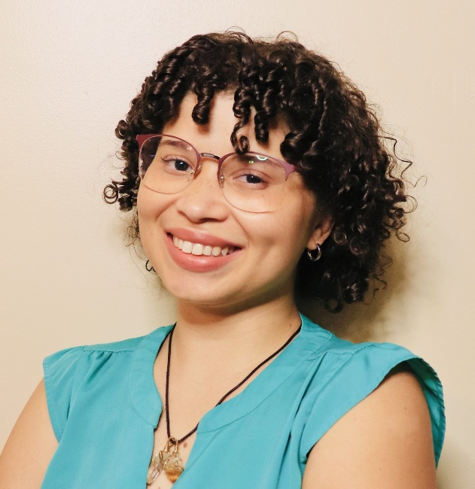

**Chenae Russell**

Chenae Russell is the Statewide Parent Cabinet Coordinator at the CT Office of Early Childhood (OEC). She helped to co-design the Parent Cabinet with parent and community leaders before establishing the agency’s 1st Parent Cabinet in 2021. This role highlights her passion to uplift the voices of those impacted by services and ensure agencies work with families to ensure systems work for families . This connects to her own personal experiences as a daughter of a single mother and a single mother herself who relied on services and navigated systems including those from OEC. The words of Maya Angelou, “You may encounter many defeats, but we must not be defeated”, have helped her to push through.

She received her Master’s Degree from UConn School Of Social Work with a focus on Community Organizing in 2020 and a Bachelor’s Degree from Goodwin University in Business Administration with a Minor in Psychology in 2018. Upon graduating, she became the first in her maternal line with a Degree while also supporting her young daughter and working part-time. Chenae had the incredible experience in her graduate education to intern at nonprofits CT Coalition Against Domestic Violence (CCADV) and formerly known CT Women’s Education and Legal Fund (CWEALF) now She Leads Justice in CT helping to guide her in her current role. Her identity is centered in her faith in God, personal growth, and the love and support of her family.