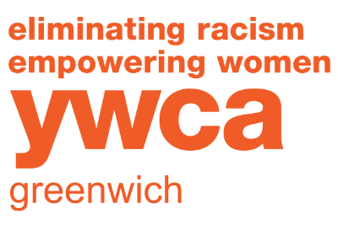

HEALTH AND SAFETY GUIDELINES FOR PRESCHOOL CAMP

- Temperature checks will be done outside the back door for ALL campers and staff each morning. Persons with temperatures registering 100> degrees, exhibiting a cough, “runny nose” or any other symptom will not be permitted to attend that day.

- Majority of activities will occur outside.

- Designated classrooms will be for the use of only one group.

- Staff will be required to wear a face covering at all times. Children under the age of 2 will not be required to wear face masks. All children aged 2, 3 and 4 will be required to wear face coverings if they exhibit any signs of illness.

- Parents WILL NOT be permitted to enter the building. Arrival and Dismissal will be done outside the back door unless instructed differently. Parents must park their cars in a parking spot and escort their child up the walkway for drop off. After the child’s temperature is taken, the child will then be escorted into the building to his/her group. Pick up will be in the main lobby. Parents of Plus children must call downstairs to the classroom prior to ringing the doorbell outside the classroom.

- ALL FORMS – Emergency Information form, Health Assessment, Authorization form, Dismissal form, Information Data sheet, Family Handbook agreement, and COVID-19 Parent Waivers must be fully completed, signed and returned to the Education Office before a child is PERMITTED TO ATTEND CAMP.

*YWCA will always consider the health and safety of the children, their families and staff as the utmost concern. YWCA reserves the right to alter and/or change these policies and procedures at any time due to the community, OEC, Department of Health and CDC guidelines.

FOR FURTHER QUESTIONS
CONTACT Geri Smiles
g.smiles@ywcagreenwich.org OR (203) 869-6501, EXT. 221

FREQUENTLY ASKED QUESTIONS

about YWCA PRESCHOOL SUMMER CAMP - 2023

Q. What is Preschool Summer 2023?
A. YWCA Preschool Camp will be an activity filled camp offered by the YWCA Greenwich for kids, ages 20 months to 5yrs old.

Q. What activities will Preschool Summer 2023 offer?
A. Your child will be involved in a wide range of exciting and fun-filled activities such as:
- Arts & Crafts
- Cooking
- Free choice time
- Outside play in our new Kompan playground
- Storytime
- Splash Pad
- Sandbox

Q. How many weeks will be offered?
A. 8 weeks of summer fun (2 4-week sessions).
June 26 - July 21
July 24 - August 18

Q. What is the cost of each camp session?
A. Please see the Tuition chart attached.

Q. What are the summer program hours (lunch bunch and extended day)?
A. The regular hours for the summer program will be: 9:00-12:00
1 hour for Lunch Bunch may be added on for all ages if there is sufficient interest.
1:00-3:30 for 3s & 4s for Extended Day may be added if there is sufficient interest.
B. Plus Program for 3s & 4s: 7:30am – 6:00pm.

Q. How do I register?
A. Complete and return the registration form via online, mail or in person. You will be billed for the total amount at the time of registration.

Q. Which group is my child eligible for?
A. Children born in these years will be accepted:
1s - 2021
2s - 2020
3s - 2019
4s - 2018 (3s and 4s may be combined depending on enrollment)

Q. Does the YWCA offer financial assistance?
A. Yes, financial assistance in the form of a scholarship for income-eligible families, as well as those affected by this Pandemic situation, is available. Please contact the Preschool Director about assistance.

YWCA Greenwich Preschool Summer Camp appreciates your cooperation as we provide a positive and healthy experience for all children!

